Test I Review: The Journey to Civilization, Ancient Mesopotamia and Ancient Egypt
Evaluation | % of Final Grade | % of Communication | % of Application | % of Knowledge and Understanding | % of Thinking
Test I: The Journey to Civilization, Ancient Mesopotamia and Ancient Egypt | 5% | 1.25% | 1.25% | 1.25% | 1.25%

Overview: The test will include three sections and they are as follows – Multiple Choice (Knowledge and Understanding), Visual Deconstruction (Thinking), Map Analysis (Application) and Reading Response (Communication).

The following review includes a sample question for each section. The test is out of twenty marks, with each section valued at 5 marks. There will be 10 multiple choice questions worth half a mark each. In each of the other sections there will be one question worth 5 marks (in certain sections you might be given a choice of the question to answer).

Sample Questions

Section I – Multiple Choice (Knowledge and Understanding 5 Marks)

In this section there will be 10 Multiple Choice questions. Following are the instructions that will appear on the test and an example question.

Instructions: Select the best answer by blacking out the letter adjacent to the best answer and then blacking out the same letter on the answer key next to the corresponding question number.

- In Sumer writing developed:
- Originally, to record taxation and trade
- Into cuneiform
- From pictographs to a syllabary to an alphabet
- All of the above

Section II – Visual Deconstruction (Thinking 5 Marks)

Instructions: Carefully view the following visuals and answer the accompanying question. Refer to the visual in the answer to the question.

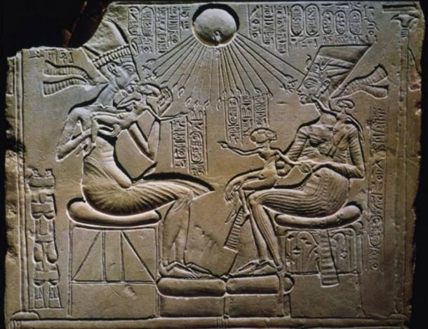

- Describe how Akhenaton defied artistic convention. Refer to the visual in the answer.

_____________________________________________________________________________________

_____________________________________________________________________________________

_____________________________________________________________________________________

_____________________________________________________________________________________

_____________________________________________________________________________________

Section III – Map Analysis (Application 5 Marks)

Instructions: Carefully view the following map and answer the accompanying question. Refer to the map in the answer to the question.

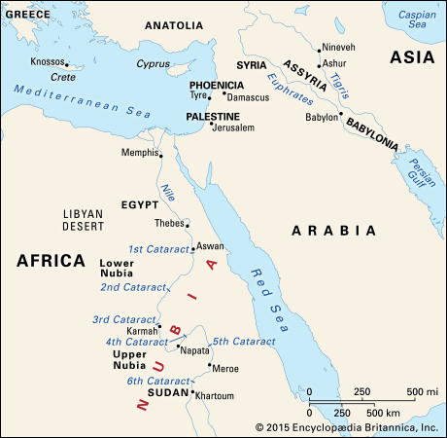

- How did the respective locations of Upper and Lower Egypt influence their interactions with foreign societies and civilizations, and, impact their development?

_____________________________________________________________________________________

_____________________________________________________________________________________

_____________________________________________________________________________________

_____________________________________________________________________________________

_____________________________________________________________________________________

Section IV – Reading Response (Communication 5 Marks)

Instructions: Carefully read the following text and answer the accompanying question. Refer to the text in your answer.

Genesis Chapter 3
[3:1] Now the serpent was more crafty than any other wild animal that the LORD God had made. He said to the woman, "Did God say, 'You shall not eat from any tree in the garden'?"
[3:2] The woman said to the serpent, "We may eat of the fruit of the trees in the garden;
[3:3] but God said, 'You shall not eat of the fruit of the tree that is in the middle of the garden, nor shall you touch it, or you shall die. '"
[3:4] But the serpent said to the woman, "You will not die;
[3:5] for God knows that when you eat of it your eyes will be opened, and you will be like God, knowing good and evil."
[3:6] So when the woman saw that the tree was good for food, and that it was a delight to the eyes, and that the tree was to be desired to make one wise, she took of its fruit and ate; and she also gave some to her husband, who was with her, and he ate.
[3:7] Then the eyes of both were opened, and they knew that they were naked; and they sewed fig leaves together and made loincloths for themselves.
[3:8] They heard the sound of the LORD God walking in the garden at the time of the evening breeze, and the man and his wife hid themselves from the presence of the LORD God among the trees of the garden.
[3:9] But the LORD God called to the man, and said to him, "Where are you?"
[3:10] He said, "I heard the sound of you in the garden, and I was afraid, because I was naked; and I hid myself."
[3:11] He said, "Who told you that you were naked? Have you eaten from the tree of which I commanded you not to eat?"
[3:12] The man said, "The woman whom you gave to be with me, she gave me fruit from the tree, and I ate."
[3:13] Then the LORD God said to the woman, "What is this that you have done?" The woman said, "The serpent tricked me, and I ate."
[3:14] The LORD God said to the serpent, "Because you have done this, cursed are you among all animals and among all wild creatures; upon your belly you shall go, and dust you shall eat all the days of your life.
[3:15] I will put enmity between you and the woman, and between your offspring and hers; he will strike your head, and you will strike his heel."
[3:16] To the woman he said, "I will greatly increase your pangs in childbearing; in pain you shall bring forth children, yet your desire shall be for your husband, and he shall rule over you."
[3:17] And to the man he said, "Because you have listened to the voice of your wife, and have eaten of the tree about which I commanded you, 'You shall not eat of it,' cursed is the ground because of you; in toil you shall eat of it all the days of your life;
[3:18] thorns and thistles it shall bring forth for you; and you shall eat the plants of the field.
[3:19] By the sweat of your face you shall eat bread until you return to the ground, for out of it you were taken; you are dust, and to dust you shall return."
[3:20] The man named his wife Eve, because she was the mother of all living.
[3:21] And the LORD God made garments of skins for the man and for his wife, and clothed them.
[3:22] Then the LORD God said, "See, the man has become like one of us, knowing good and evil; and now, he might reach out his hand and take also from the tree of life, and eat, and live forever"--
[3:23] therefore the LORD God sent him forth from the garden of Eden, to till the ground from which he was taken.
[3:24] He drove out the man; and at the east of the garden of Eden he placed the cherubim, and a sword flaming and turning to guard the way to the tree of life.

- Describe how the story of the expulsion from the Garden of Eden may allude to the transition from Hunter Gatherer to Civilization? What burdens are placed upon humankind?

_____________________________________________________________________________________

_____________________________________________________________________________________

_____________________________________________________________________________________

_____________________________________________________________________________________

_____________________________________________________________________________________

Overall Review with Topics of Importance

You should have knowledge of the following topics:

- Evolution of humans – Australopithecus, Lucy, Homo Habilis, Homo Erectus, Neanderthals, Denisovans, Homo Floresiensis , Homo Sapiens
- The Paleolithic
- The Cognitive Revolution – Cave paintings, Tool and Clothing Improvements
- Neolithic Revolution – Reasons, Plant and Animal Domestication, Gobekli Tepe, Jericho, Catal Huyuk
- Elements of a Civilization – Agricultural Intensification, Science and Technology, Artisan and Craftsman, Trade and Commerce, Social Hierarchy, Government and Laws, Religion
- Sumerian Civilization – The Development of Writing, Ziggurats, Ur and Uruk, Gilgamesh, Gods and Religion, Collapse of Farming and Decline
- Babylonian and Assyrian Civilization – The Tower of Babyl, the Hanging Gardens, The Ishtar Gate, Hammurabi’s Code, Nebuchadnezzar II
- Egyptian Civilization (Early Dynastic) – Menes (Narmar), the unification of Upper and Lower Egypt, Mastabas, Memphis
- Egyptian Civilization (The Old Kingdom) – Djoser, Step Pyramid, Imhotep (architecture and medicine), Viziers, Sneferu, Pyramid at Meidum, Bent Pyramid, Red Pyramid, Saqqara, Khufu, the Great Pyramid, the Sphinx, Khafra, Menkaure, Giza, First Intermediate Period, Nomarchs
- Egyptian Civilization (Middle Kingdom) – Mentuhotep II, Mentuhotep IV vs. Amenemhot I, Senusret III, Sobekneferu, Second Intermediate Period, Hyksos Invasion
- Egyptian Civilization (New Kingdom) – Ahmose, Thebes, Hatshepsut, Valley of the Kings, Thutmose III, Akhenaton, Tutankhamen, Ramses II, Sea People, Kadesh
- Egyptian Civilization – Daily Life in Home and in Town, Mummification, Pyramids, In Temple, Party, Hieroglyphs
- Ancient Israel – Abraham, Moses, David, Solomon, Jerusalem, the First and Second Temple, the Old Testament

