Test II Review: Classical Civilization – Ancient Greece and Ancient Rome
Evaluation | % of Final Grade | % of Communication | % of Application | % of Knowledge and Understanding | % of Thinking
Test I: The Journey to Civilization, Ancient Mesopotamia and Ancient Egypt | 5% | 1.25% | 1.25% | 1.25% | 1.25%

Overview: The test will include three sections and they are as follows – Multiple Choice (Knowledge and Understanding), Visual Deconstruction (Thinking), Map Analysis (Application) and Reading Response (Communication).

The following review includes a sample question for each section. The test is out of twenty marks, with each section valued at 5 marks. There will be 10 multiple choice questions worth half a mark each. In each of the other sections there will be one question worth 5 marks (in certain sections you might be given a choice of the question to answer).

Sample Questions

Section I – Multiple Choice (Knowledge and Understanding 5 Marks)

In this section there will be 10 Multiple Choice questions. Following are the instructions that will appear on the test and an example question.

Instructions: Select the best answer by blacking out the letter adjacent to the best answer and then blacking out the same letter on the answer key next to the corresponding question number.

- Herodotus and Thucydides differ in that:
- Most famously, Herodotus wrote of the Persian Wars and Thucydides wrote of the Peloponnesian Wars
- The ‘facts’ recorded by Herodotus include more instances of hyperbole and mythologizing
- Thucydides preceded Herodotus
- All of the above
- Both a and b

Section II – Visual Deconstruction (Thinking 5 Marks)

Instructions: Carefully view the following visuals and answer the accompanying question. Refer to the visual in the answer to the question.

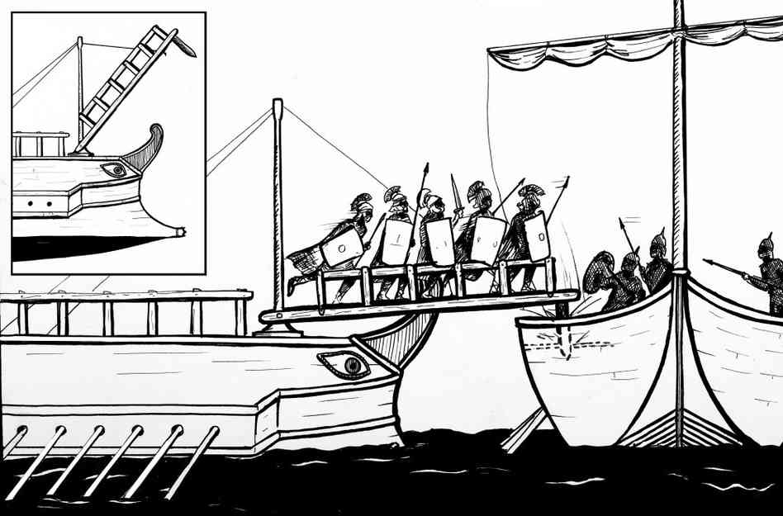

- Identify the device attached to the mast of the Roman ship and explain why it was imperative for Roman success during the Punic Wars.

__________________________________________________________________________________

__________________________________________________________________________________

__________________________________________________________________________________

__________________________________________________________________________________

__________________________________________________________________________________

__________________________________________________________________________________

Section III – Map Analysis (Application 5 Marks)

Instructions: Carefully view the following map and answer the accompanying question. Refer to the map in the answer to the question.

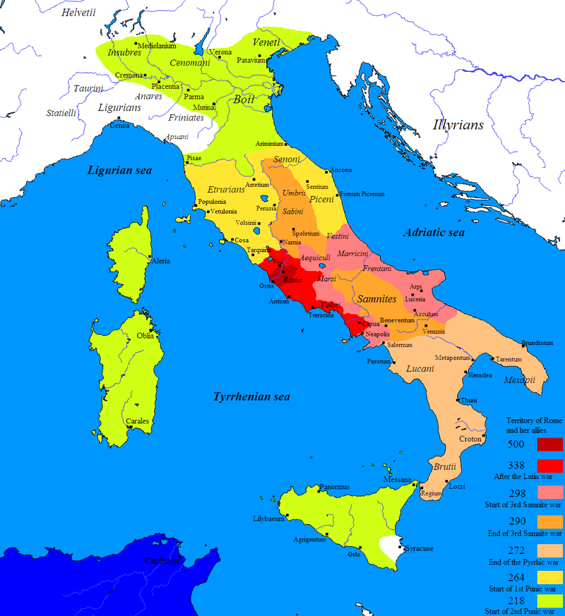

- Offer three reasons as to why the position of Rome on the Italian peninsula so advantageous?

__________________________________________________________________________________

__________________________________________________________________________________

__________________________________________________________________________________

__________________________________________________________________________________
Section IV – Reading Response (Communication 5 Marks)

Instructions: Carefully read the following text and answer the accompanying question. Refer to the text in your answer.

History of the Peloponnesian War – The Mytilenean Debate (Thucydides)
25. Towards the close of the same winter, Salaethus, a Lacedaemonian, was sent out in a galley from Lacedaemon to Mytilene. Going by sea to Pyrrha, and from thence overland, he passed along the bed of a torrent, where the line of circumvallation was passable, and thus entering unperceived into Mytilene told the magistrates that Attica would certainly be invaded, and the forty ships destined to relieve them arrive, and that he had been sent on to announce this and to superintend matters generally. The Mytilenians upon this took courage, and laid aside the idea of treating with the Athenians; and now this winter ended, and with it ended the fourth year of the war of which Thucydides was the historian.
26. The next summer the Peloponnesians sent off the forty-two ships for Mytilene, under Alcidas, their high admiral, and themselves and their allies invaded Attica, their object being to distract the Athenians by a double movement, and thus to make it less easy for them to act against the fleet sailing to Mytilene. The commander in this invasion was Cleomenes, in the place of King Pausanias, son of Pleistoanax, his nephew, who was still a minor. Not content with laying waste whatever had shot up in the parts which they had before devastated, the invaders now extended their ravages to lands passed over in their previous incursions; so that this invasion was more severely felt by the Athenians than any except the second; the enemy staying on and on until they had overrun most of the country, in the expectation of hearing from Lesbos of something having been achieved by their fleet, which they thought must now have got over. However, as they did not obtain any of the results expected, and their provisions began to run short, they retreated and dispersed to their different cities.
27. In the meantime the Mytilenians, finding their provisions failing, while the fleet from Peloponnese was loitering on the way instead of appearing at Mytilene, were compelled to come to terms with the Athenians in the following manner. Salaethus having himself ceased to expect the fleet to arrive, now armed the commons with heavy armour, which they had not before possessed, with the intention of making a sortie against the Athenians. The commons, however, no sooner found themselves possessed of arms than they refused any longer to obey their officers; and forming in knots together, told the authorities to bring out in public the provisions and divide them amongst them all, or they would themselves come to terms with the Athenians and deliver up the city.
28. The government, aware of their inability to prevent this, and of the danger they would be in, if left out of the capitulation, publicly agreed with Paches and the army to surrender Mytilene at discretion and to admit the troops into the town; upon the understanding that the Mytilenians should be allowed to send an embassy to Athens to plead their cause, and that Paches should not imprison, make slaves of, or put to death any of the citizens until its return. Such were the terms of the capitulation; in spite of which the chief authors of the negotiation with Lacedaemon were so completely overcome by terror when the army entered that they went and seated themselves by the altars, from which they were raised up by Paches under promise that he would do them no wrong, and lodged by him in Tenedos, until he should learn the pleasure of the Athenians concerning them. Paches also sent some galleys and seized Antissa, and took such other military measures as he thought advisable.
* * *
35. Arrived at Mytilene, Paches reduced Pyrrha and Eresus; and finding the Lacedaemonian, Salaethus, in hiding in the town, sent him off to Athens, together with the Mytilenians that he had placed in Tenedos, and any other persons that he thought concerned in the revolt. He also sent back the greater part of his forces, remaining with the rest to settle Mytilene and the rest of Lesbos as he thought best.
36. Upon the arrival of the prisoners with Salaethus, the Athenians at once put the latter to death, although he offered, among other things, to procure the withdrawal of the Peloponnesians from Plataea, which was still under siege; and after deliberating as to what they should do with the former, in the fury of the moment determined to put to death not only the prisoners at Athens, but the whole adult male population of Mytilene, and to make slaves of the women and children. It was remarked that Mytilene had revolted without being, like the rest, subjected to the empire; and what above all swelled the wrath of the Athenians was the fact of the Peloponnesian fleet having ventured over to Ionia to her support, a fact which was held to argue a long meditated rebellion. They accordingly sent a galley to communicate the decree to Paches, commanding him to lose no time in dispatching the Mytilenians. The morrow brought repentance with it and reflection on the horrid cruelty of a decree, which condemned a whole city to the fate merited only by the guilty. This was no sooner perceived by the Mytilenian ambassadors at Athens and their Athenian supporters, than they moved the authorities to put the question again to the vote; which they the more easily consented to do, as they themselves plainly saw that most of the citizens wished some one to give them an opportunity for reconsidering the matter. An assembly was therefore at once called, and after much expression of opinion upon both sides, Cleon, son of Cleaenetus, the same who had carried the former motion of putting the Mytilenians to death, the most violent man at Athens, and at that time by far the most powerful with the commons, came forward again and spoke as follows:
37. "I have often before now been convinced that a democracy is incapable of empire, and never more so than by your present change of mind in the matter of Mytilene. Fears or plots being unknown to you in your daily relations with each other, you feel just the same with regard to your allies, and never reflect that the mistakes into which you may be led by listening to their appeals, or by giving way to your own compassion, are full of danger to yourselves, and bring you no thanks for your weakness from your allies; entirely forgetting that your empire is a despotism and your subjects disaffected conspirators, whose obedience is ensured not by your suicidal concessions, but by the superiority given you by your own strength and not their loyalty. The most alarming feature in the case is the constant change of measures with which we appear to be threatened, and our seeming ignorance of the fact that bad laws which are never changed are better for a city than good ones that have no authority; that unlearned loyalty is more serviceable than quick-witted insubordination; and that ordinary men usually manage public affairs better than their more gifted fellows. The latter are always wanting to appear wiser than the laws, and to overrule every proposition brought forward, thinking that they cannot show their wit in more important matters, and by such behaviour too often ruin their country; while those who mistrust their own cleverness are content to be less learned than the laws, and less able to pick holes in the speech of a good speaker; and being fair judges rather than rival athletes, generally conduct affairs successfully. These we ought to imitate, instead of being led on by cleverness and intellectual rivalry to advise your people against our real opinions.
38. "For myself, I adhere to my former opinion, and wonder at those who have proposed to reopen the case of the Mytilenians, and who are thus causing a delay which is all in favour of the guilty, by making the sufferer proceed against the offender with the edge of his anger blunted; although where vengeance follows most closely upon the wrong, it best equals it and most amply requites it. I wonder also who will be the man who will maintain the contrary, and will pretend to show that the crimes of the Mytilenians are of service to us, and our misfortunes injurious to the allies. Such a man must plainly either have such confidence in his rhetoric as to adventure to prove that what has been once for all decided is still undetermined, or be bribed to try to delude us by elaborate sophisms. In such contests the state gives the rewards to others, and takes the dangers for herself. The persons to blame are you who are so foolish as to institute these contests; who go to see an oration as you would to see a sight, take your facts on hearsay, judge of the practicability of a project by the wit of its advocates, and trust for the truth as to past events not to the fact which you saw more than to the clever strictures which you heard; the easy victims of new-fangled arguments, unwilling to follow received conclusions; slaves to every new paradox, despisers of the commonplace; the first wish of every man being that he could speak himself, the next to rival those who can speak by seeming to be quite up with their ideas by applauding every hit almost before it is made, and by being as quick in catching an argument as you are slow in foreseeing its consequences; asking, if I may so say, for something different from the conditions under which we live, and yet comprehending inadequately those very conditions; very slaves to the pleasure of the ear, and more like the audience of a rhetorician than the council of a city.
39. "In order to keep you from this, I proceed to show that no one state has ever injured you as much as Mytilene. I can make allowance for those who revolt because they cannot bear our empire, or who have been forced to do so by the enemy. But for those who possessed an island with fortifications; who could fear our enemies only by sea, and there had their own force of galleys to protect them; who were independent and held in the highest honour by you—to act as these have done, this is not revolt—revolt implies oppression; it is deliberate and wanton aggression; an attempt to ruin us by siding with our bitterest enemies; a worse offence than a war undertaken on their own account in the acquisition of power. The fate of those of their neighbours who had already rebelled and had been subdued was no lesson to them; their own prosperity could not dissuade them from affronting danger; but blindly confident in the future, and full of hopes beyond their power though not beyond their ambition, they declared war and made their decision to prefer might to right, their attack being determined not by provocation but by the moment which seemed propitious. The truth is that great good fortune coming suddenly and unexpectedly tends to make a people insolent; in most cases it is safer for mankind to have success in reason than out of reason; and it is easier for them, one may say, to stave off adversity than to preserve prosperity. Our mistake has been to distinguish the Mytilenians as we have done: had they been long ago treated like the rest, they never would have so far forgotten themselves, human nature being as surely made arrogant by consideration as it is awed by firmness. Let them now therefore be punished as their crime requires, and do not, while you condemn the aristocracy, absolve the people. This is certain, that all attacked you without distinction, although they might have come over to us and been now again in possession of their city. But no, they thought it safer to throw in their lot with the aristocracy and so joined their rebellion! Consider therefore: if you subject to the same punishment the ally who is forced to rebel by the enemy, and him who does so by his own free choice, which of them, think you, is there that will not rebel upon the slightest pretext; when the reward of success is freedom, and the penalty of failure nothing so very terrible? We meanwhile shall have to risk our money and our lives against one state after another; and if successful, shall receive a ruined town from which we can no longer draw the revenue upon which our strength depends; while if unsuccessful, we shall have an enemy the more upon our hands, and shall spend the time that might be employed in combating our existing foes in warring with our own allies.
40. "No hope, therefore, that rhetoric may instil or money purchase, of the mercy due to human infirmity must be held out to the Mytilenians. Their offence was not involuntary, but of malice and deliberate; and mercy is only for unwilling offenders. I therefore, now as before, persist against your reversing your first decision, or giving way to the three failings most fatal to empire—pity, sentiment, and indulgence. Compassion is due to those who can reciprocate the feeling, not to those who will never pity us in return, but are our natural and necessary foes: the orators who charm us with sentiment may find other less important arenas for their talents, in the place of one where the city pays a heavy penalty for a momentary pleasure, themselves receiving fine acknowledgments for their fine phrases; while indulgence should be shown towards those who will be our friends in future, instead of towards men who will remain just what they were, and as much our enemies as before. To sum up shortly, I say that if you follow my advice you will do what is just towards the Mytilenians, and at the same time expedient; while by a different decision you will not oblige them so much as pass sentence upon yourselves. For if they were right in rebelling, you must be wrong in ruling. However, if, right or wrong, you determine to rule, you must carry out your principle and punish the Mytilenians as your interest requires; or else you must give up your empire and cultivate honesty without danger. Make up your minds, therefore, to give them like for like; and do not let the victims who escaped the plot be more insensible than the conspirators who hatched it; but reflect what they would have done if victorious over you, especially they were the aggressors. It is they who wrong their neighbour without a cause, that pursue their victim to the death, on account of the danger which they foresee in letting their enemy survive; since the object of a wanton wrong is more dangerous, if he escape, than an enemy who has not this to complain of. Do not, therefore, be traitors to yourselves, but recall as nearly as possible the moment of suffering and the supreme importance which you then attached to their reduction; and now pay them back in their turn, without yielding to present weakness or forgetting the peril that once hung over you. Punish them as they deserve, and teach your other allies by a striking example that the penalty of rebellion is death. Let them once understand this and you will not have so often to neglect your enemies while you are fighting with your own confederates."
41. Such were the words of Cleon. After him Diodotus, son of Eucrates, who had also in the previous assembly spoken most strongly against putting the Mytilenians to death, came forward and spoke as follows:
42. "I do not blame the persons who have reopened the case of the Mytilenians, nor do I approve the protests which we have heard against important questions being frequently debated. I think the two things most opposed to good counsel are haste and passion; haste usually goes hand in hand with folly, passion with coarseness and narrowness of mind. As for the argument that speech ought not to be the exponent of action, the man who uses it must be either senseless or interested: senseless if he believes it possible to treat of the uncertain future through any other medium; interested if, wishing to carry a disgraceful measure and doubting his ability to speak well in a bad cause, he thinks to frighten opponents and hearers by well-aimed calumny. What is still more intolerable is to accuse a speaker of making a display in order to be paid for it. If ignorance only were imputed, an unsuccessful speaker might retire with a reputation for honesty, if not for wisdom; while the charge of dishonesty makes him suspected, if successful, and thought, if defeated, not only a fool but a rogue. The city is no gainer by such a system, since fear deprives it of its advisers; although in truth, if our speakers are to make such assertions, it would be better for the country if they could not speak at all, as we should then make fewer blunders. The good citizen ought to triumph not by frightening his opponents but by beating them fairly in argument; and a wise city, without over-distinguishing its best advisers, will nevertheless not deprive them of their due, and, far from punishing an unlucky counsellor, will not even regard him as disgraced. In this way successful orators would be least tempted to sacrifice their convictions to popularity, in the hope of still higher honours, and unsuccessful speakers to resort to the same popular arts in order to win over the multitude.
43. "This is not our way; and, besides, the moment that a man is suspected of giving advice, however good, from corrupt motives, we feel such a grudge against him for the gain which after all we are not certain he will receive, that we deprive the city of its certain benefit. Plain good advice has thus come to be no less suspected than bad; and the advocate of the most monstrous measures is not more obliged to use deceit to gain the people, than the best counsellor is to lie in order to be believed. The city and the city only, owing to these refinements, can never be served openly and without disguise; he who does serve it openly being always suspected of serving himself in some secret way in return. Still, considering the magnitude of the interests involved, and the position of affairs, we orators must make it our business to look a little farther than you who judge offhand; especially as we, your advisers, are responsible, while you, our audience, are not so. For if those who gave the advice, and those who took it, suffered equally, you would judge more calmly; as it is, you visit the disasters into which the whim of the moment may have led you upon the single person of your adviser, not upon yourselves, his numerous companions in error.
44. "However, I have not come forward either to oppose or to accuse in the matter of Mytilene; indeed, the question before us as sensible men is not their guilt, but our interests. Though I prove them ever so guilty, I shall not, therefore, advise their death, unless it be expedient; nor though they should have claims to indulgence, shall I recommend it, unless it be dearly for the good of the country. I consider that we are deliberating for the future more than for the present; and where Cleon is so positive as to the useful deterrent effects that will follow from making rebellion capital, I, who consider the interests of the future quite as much as he, as positively maintain the contrary. And I require you not to reject my useful considerations for his specious ones: his speech may have the attraction of seeming the more just in your present temper against Mytilene; but we are not in a court of justice, but in a political assembly; and the question is not justice, but how to make the Mytilenians useful to Athens.
45. "Now of course communities have enacted the penalty of death for many offences far lighter than this: still hope leads men to venture, and no one ever yet put himself in peril without the inward conviction that he would succeed in his design. Again, was there ever city rebelling that did not believe that it possessed either in itself or in its alliances resources adequate to the enterprise? All, states and individuals, are alike prone to err, and there is no law that will prevent them; or why should men have exhausted the list of punishments in search of enactments to protect them from evildoers? It is probable that in early times the penalties for the greatest offences were less severe, and that, as these were disregarded, the penalty of death has been by degrees in most cases arrived at, which is itself disregarded in like manner. Either then some means of terror more terrible than this must be discovered, or it must be owned that this restraint is useless; and that as long as poverty gives men the courage of necessity, or plenty fills them with the ambition which belongs to insolence and pride, and the other conditions of life remain each under the thraldom of some fatal and master passion, so long will the impulse never be wanting to drive men into danger. Hope also and cupidity, the one leading and the other following, the one conceiving the attempt, the other suggesting the facility of succeeding, cause the widest ruin, and, although invisible agents, are far stronger than the dangers that are seen. Fortune, too, powerfully helps the delusion and, by the unexpected aid that she sometimes lends, tempts men to venture with inferior means; and this is especially the case with communities, because the stakes played for are the highest, freedom or empire, and, when all are acting together, each man irrationally magnifies his own capacity. In fine, it is impossible to prevent, and only great simplicity can hope to prevent, human nature doing what it has once set its mind upon, by force of law or by any other deterrent force whatsoever.
46. "We must not, therefore, commit ourselves to a false policy through a belief in the efficacy of the punishment of death, or exclude rebels from the hope of repentance and an early atonement of their error. Consider a moment. At present, if a city that has already revolted perceive that it cannot succeed, it will come to terms while it is still able to refund expenses, and pay tribute afterwards. In the other case, what city, think you, would not prepare better than is now done, and hold out to the last against its besiegers, if it is all one whether it surrender late or soon? And how can it be otherwise than hurtful to us to be put to the expense of a siege, because surrender is out of the question; and if we take the city, to receive a ruined town from which we can no longer draw the revenue which forms our real strength against the enemy? We must not, therefore, sit as strict judges of the offenders to our own prejudice, but rather see how by moderate chastisements we may be enabled to benefit in future by the revenue-producing powers of our dependencies; and we must make up our minds to look for our protection not to legal terrors but to careful administration. At present we do exactly the opposite. When a free community, held in subjection by force, rises, as is only natural, and asserts its independence, it is no sooner reduced than we fancy ourselves obliged to punish it severely; although the right course with freemen is not to chastise them rigorously when they do rise, but rigorously to watch them before they rise, and to prevent their ever entertaining the idea, and, the insurrection suppressed, to make as few responsible for it as possible.
47. "Only consider what a blunder you would commit in doing as Cleon recommends. As things are at present, in all the cities the people is your friend, and either does not revolt with the oligarchy, or, if forced to do so, becomes at once the enemy of the insurgents; so that in the war with the hostile city you have the masses on your side. But if you butcher the people of Mytilene, who had nothing to do with the revolt, and who, as soon as they got arms, of their own motion surrendered the town, first you will commit the crime of killing your benefactors; and next you will play directly into the hands of the higher classes, who when they induce their cities to rise, will immediately have the people on their side, through your having announced in advance the same punishment for those who are guilty and for those who are not. On the contrary, even if they were guilty, you ought to seem not to notice it, in order to avoid alienating the only class still friendly to us. In short, I consider it far more useful for the preservation of our empire voluntarily to put up with injustice, than to put to death, however justly, those whom it is our interest to keep alive. As for Cleon's idea that in punishment the claims of justice and expediency can both be satisfied, facts do not confirm the possibility of such a combination.
48. "Confess, therefore, that this is the wisest course, and without conceding too much either to pity or to indulgence, by neither of which motives do I any more than Cleon wish you to be influenced, upon the plain merits of the case before you, be persuaded by me to try calmly those of the Mytileneans whom Paches sent off as guilty, and to leave the rest undisturbed. This is at once best for the future, and most terrible to your enemies at the present moment; inasmuch as good policy against an adversary is superior to the blind attacks of brute force."
49. Such were the words of Diodotus. The two opinions thus expressed were the ones that most directly contradicted each other; and the Athenians, notwithstanding their change of feeling, now proceeded to a division, in which the show of hands was almost equal, although the motion of Diodotus carried the day. Another galley was at once sent off in haste, for fear that the first might reach Lesbos in the interval, and the city be found destroyed; the first ship having about a day and a night's start. Wine and barley-cakes were provided for the vessel by the Mytilenian ambassadors, and great promises made if they arrived in time; which caused the men to use such diligence upon the voyage that they took their meals of barley-cakes kneaded with oil and wine as they rowed, and only slept by turns while the others were at the oar. Luckily they met with no contrary wind, and the first ship making no haste upon so horrid an errand, while the second pressed on in the manner described, the first arrived so little before them, that Paches had only just had time to read the decree, and to prepare to execute the sentence, when the second put into port and prevented the massacre. The danger of Mytilene had indeed been great.
50. The other party whom Paches had sent off as the prime movers in the rebellion, were upon Cleon's motion put to death by the Athenians, the number being rather more than a thousand. The Athenians also demolished the walls of the Mytilenians, and took possession of their ships. Afterwards tribute was not imposed upon the Lesbians; but all their land, except that of the Methymnians, was divided into three thousand allotments, three hundred of which were reserved as sacred for the gods, and the rest assigned by lot to Athenian shareholders, who were sent out to the island. With these the Lesbians agreed to pay a rent of two minae a year for each allotment, and cultivated the land themselves. The Athenians also took possession of the towns on the continent belonging to the Mytilenians, which thus became for the future subject to Athens. Such were the events that took place at Lesbos.
(Thucydides, History of the Peloponnesian War 3.25-28 & 35-50.)

- Summarize the arguments of Cleon and Diodotus. Which of the two do you agree with and why?

_________________________________________________________________________________

_________________________________________________________________________________

_________________________________________________________________________________

_________________________________________________________________________________

__________________________________________________________________________________

Overall Review with Topics of Importance

You should have knowledge of the following topics:

- Phoenicians – Trade, Alphabet
- Minoans – Palaces and Knossos, frescoes, the Minotaur, Bull Leaping, Linear A, Thera, Mycenaeans
- The Late Bronze Age Collapse – Drought, Sea Peoples
- The Trojan War – Achilles vs. Odysseus, Heinrich Schliemann, Archeology vs. Mythology
- The Greek Dark Ages – Migration, Colonization, Dorian, Ionian, Writing
- Geography of Greece – Terrain, Cities
- Greek Mythology – Gods and Lessons
- Athens – Assembly, Use of Coins, Cleisthenes, Solon, Draco
- Sparta – Political System, Militarization, Lycurgus, Helots
- The Persian Wars – Cyrus, Darius, Xerxes, Ionian Revolt, Marathon, Thermopylae, Salamis, Miltiades, Themistocles
- The Athenian Golden Age – Architecture, Theatre, Pericles
- The Peloponnesian Wars – Delian League, Pericles, The Plague of Athens, Nicias, Alcibiades, Syracuse Campaign, Aegospotami
- Philosophy – Natural Philosophers, Socrates, Trial of Socrates, Plato, The Academy, Aristotle, Epicurus, Epicureans, Zeno, Stoics, Diogenes, Cynics
- Alexander the Great – Macedon, Phillip, Siege of Tyre, Gaugamela, India
- Geography of Rome and Italy
- Roman Mythology – Founding Myth, Gods, The Roman Ideal
- The Roman Republic – Patricians, Plebeians, The Senate, The Consuls, The Tribune
- The Punic Wars – Carthage, Hannibal, Zama, Trasimene, Cannae
- From Republic to Empire – Brothers Gracchi, Marius, Sulla, Cicero, Caesar, Augustus, Antony, Cato
- The Good News – Jesus Christ, Paul, The Gospels, Conversion
- The Roman Empire – Julio Claudian Dynasty, Year of Four Emperors, Five Good Emperors
- The Decline – Commodus, Diocletian, Constantine, Crisis of the Third Century, The Fall of the Western Empire

